API Documentation

Alternative website builders other than WordPress and Shopify:

Other interfaces for example Prestashop, Joomla, NopCommerce, WIX, ECWID, square space, DEKAT, site123, Duda, Opencart and Netcash Shop you would need the API documentation and a web developer.

This document is for The Courier Guy API…

What is an API? (The "Simple" Version)
Think of an API (Application Programming Interface) as a digital messenger or a website link.
If you have a website (like Shopify or WooCommerce) and it "talks" to The Courier Guy to automatically create shipping labels or show delivery prices, that "conversation" happens through an API.

The Courier Guy does have access to PUDO lockers, however, they do have different API endpoints, customer databases, domains and not all staff have access to PUDO system.

Pick Up Drop Off (PUDO)
PUDO support email = support@pudo.co.za
PUDO integrations email = integrations@tcglocker.co.za
PUDO login = https://customer.pudo.co.za/login
PUDO login = https://customer.tcglocker.co.za
PUDO sandbox API = https://sandbox.api-pudo.co.za/api/v1/rates
PUDO live API = https://api-pudo.co.za/api/v1/rates (remove "sandbox.")
PUDO API documentation = https://api-pudo.co.za/

The Courier Guy (TCG)
TCG support email = support@thecourierguy.co.za
TCG integration email = it@thecourierguy.co.za
TCG login page = https://portal.thecourierguy.co.za/login
TCG API sandbox = https://api.shiplogic.com/
TCG API live = https://api.portal.thecourierguy.co.za/
Sanbox API documentation = https://www.shiplogic.com/api-docs
Live API documentation = https://thecourierguy.co.za/api-docs/

Sandbox account (Sandbox = Testing)

We've set a sandbox environment (Sandbox Couriers) for you to experiment with.
Please note that in the sandbox environment prices are demo prices, adding 100 products will not increase the test price.
IMPORTANT NOTE:
In sandbox the ECO rate/service can and will work anywhere in South Africa….not on the live site…you must specify the correct service for local, national and regional deliveries, example LOX, ECO and ECOR
When you switch to the live environment by using the API key from live account, ECO will not work everywhere in South Africa. (You could get service unavailable error)
Always cancel your test shipments even on sandbox otherwise you will end up getting a sandbox invoice every month, which you can ignore, add to your block list or login to your sandbox account and then cancel all your test shipments to reset the balance to zero.

Where to register a live or sandbox (test) account

You can register a new live account here = https://portal.thecourierguy.co.za/register
You can register a free Sandbox account here = https://sandbox.shiplogic.com/register

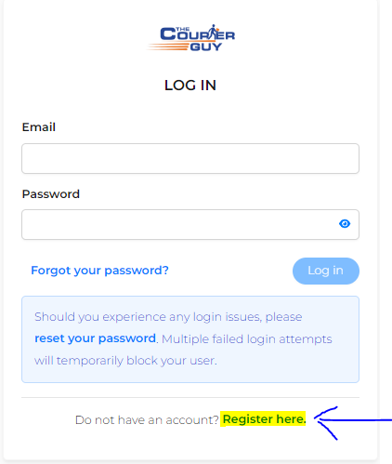

You will need a South African mobile number to register

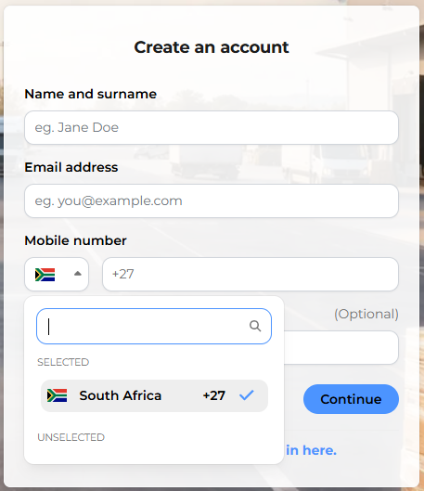

The default rate when you register online is the national one rate
For different account rates please email sales@thecourierguy.co.za

Important: Please always cancel test shipment on The Courier Guy live and on Sandbox

Important! -> Shipments cannot be cancelled when a driver fails a collection attempt, you will need to email staff to cancel.

Log into The Courier Guy and cancel the shipment (The cost will be reversed)
Right click on the shipment to cancel

Select “Manage shipment” -> “Cancel shipment”
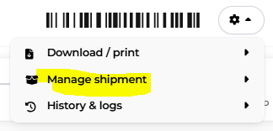
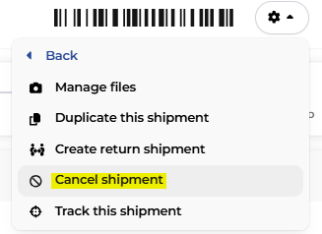

Please note international testing will not work on the Sandbox, there is no international geo-mapping.

Sandbox also has no pickup points or kiosk and very few test lockers
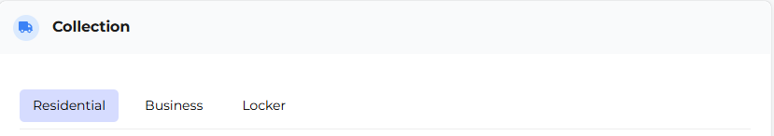

Limited lockers on sandbox

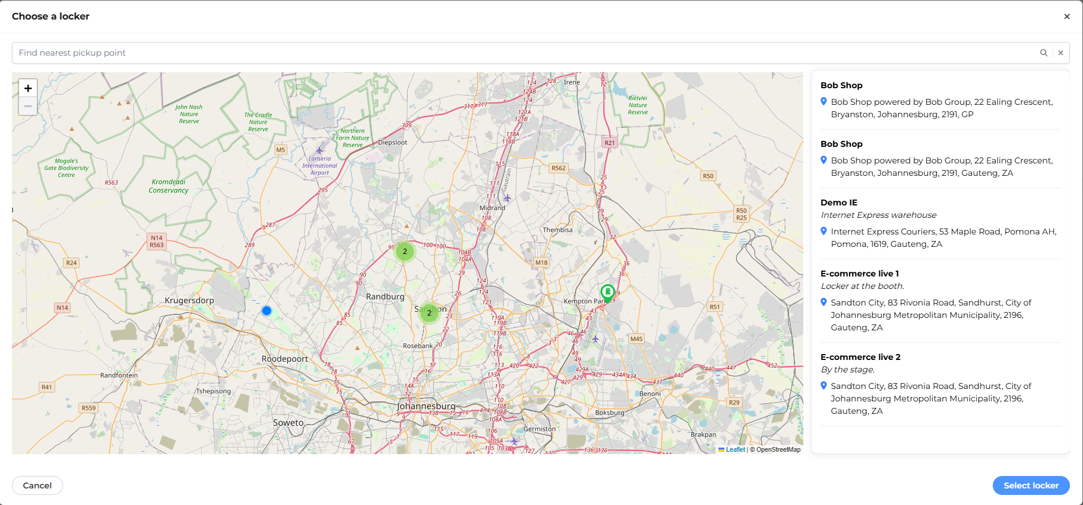

Live has “Kiosk”, “Point” and “International”
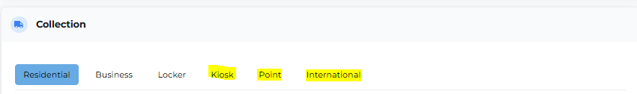

“Collection” locker, Kiosk and point can be “any” because you will need to go there to drop off…. it can be left blank on our website
“View locations” is for your reference as to where you can go, you will not be able to select anything, you will only have an option to close.

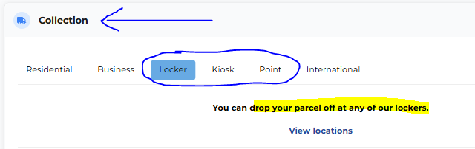

Live example for “delivery” locker…here you will have an option to select a locker.

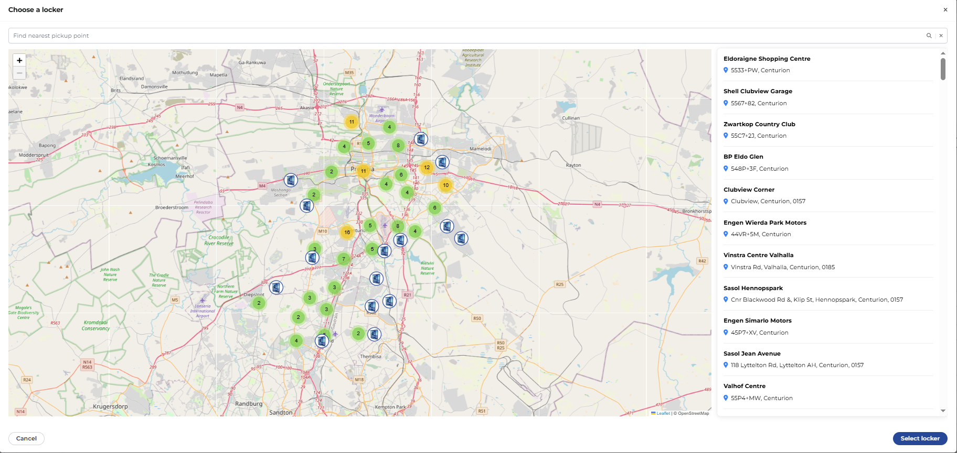

To create the API key = access bearer token

Login to your account as “account owner” role… The Courier Guy = https://portal.thecourierguy.co.za/login (make sure your time is correct on your PC)

To navigate to the below “Integrations” page, on the top left navigation panel, go to the API Keys section to view the page.
New bearer token use this API end point https://api.shiplogic.com/v2/rates (click on the button “+ Create API key” to create an “Access/Bearer Token”)
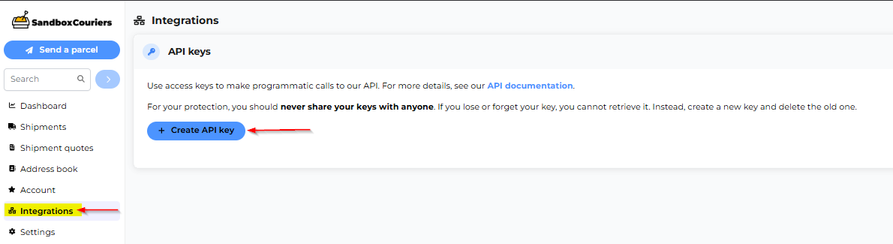
You can leave the username blank and click on “Create API key”
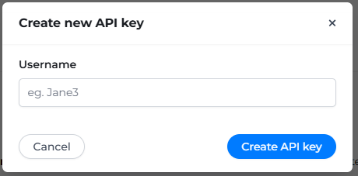

Example of name if left blank = defaults to full username of person creating the key

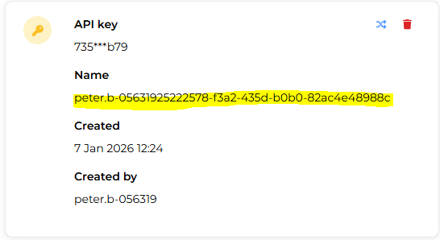

Example if unique name is added -> this makes it easier to confirm when a shipment is created using the API key

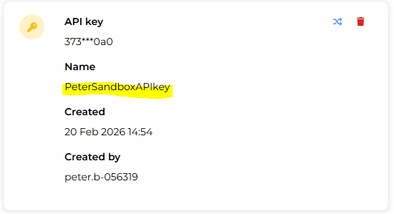

Example where named API key is used
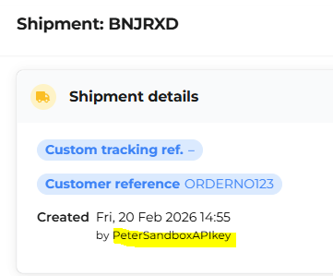

Customers can now use api.portal.thecourierguy.co.za instead of api.shiplogic.com for API requests. (Important! Please note they are phasing out “api.shiplogic.com”)

Below API endpoint will only work for sandbox API key
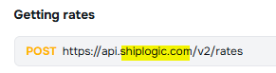

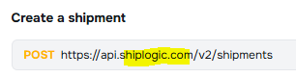

API endpoint test for live https://api.portal.thecourierguy.co.za/v2/rates

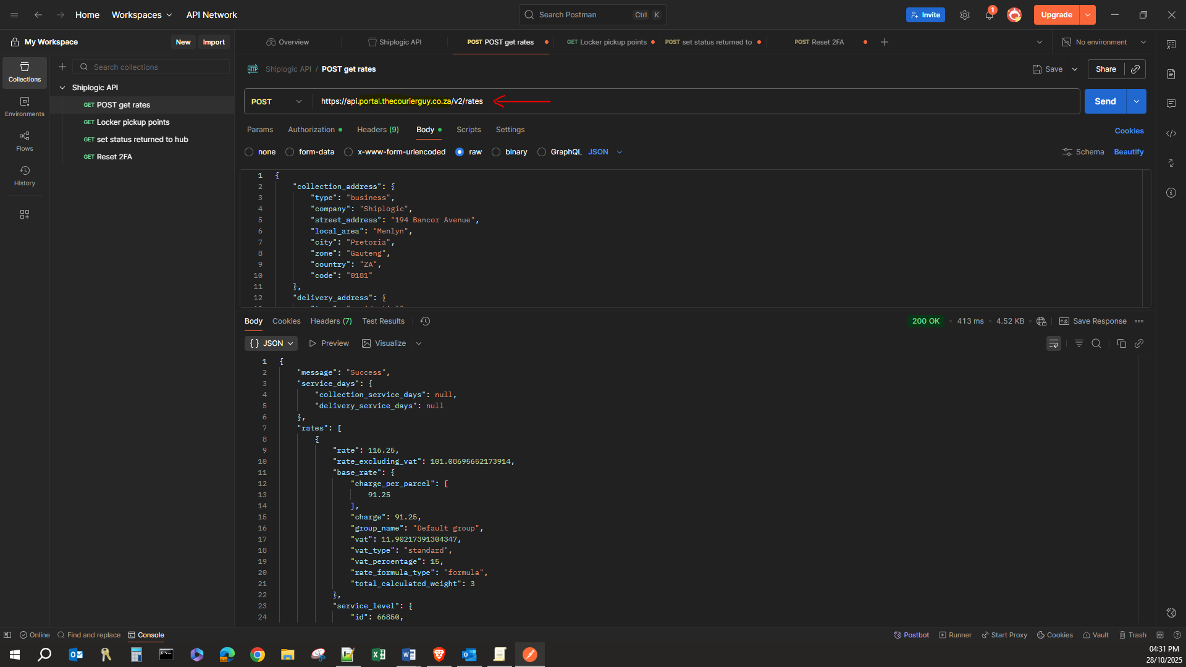

Waybill Address Format example

"company": "",
"type": "business",
"street_address": "81 Ridge Road",
"local_area": "La Lucia",
"city": "Durban",
"zone": "KwaZulu-Natal",
"country": "ZA",
"code": "4051"

This will populate the correct fields on the waybill as shown below

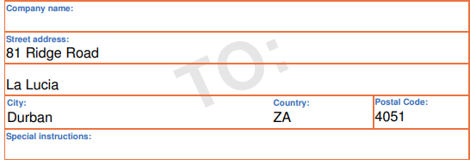

Please note that the company name is not a required field, but will be checked on Google maps as the address for example “KFC Kyalami” will work

Street address, suburb, city and province fields are required fields

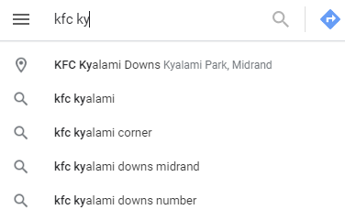

Full body postman example
{
"collection_address":{
"type": "business",
"company": "uAfrica.com",
"street_address": "116 Lois Avenue",
"local_area": "Menlyn",
"city": "Pretoria",
"code": "0181",
"zone": "Gauteng",
"country": "ZA",
},
"collection_contact": {
"name": "Cornel Rautenbach",
"mobile_number": "",
"email": "support@uafrica.com"
}
"delivery_address":{
"company":"test",
"street_address":"test",
"type":"business",
"local_area":"Durbanville",
"zone":"WC",
"country":"ZA",
"code":"7550"
},
"delivery_contact": {
"name": "",
"mobile_number": "",
"email": "cornel+sandyreceiver@uafrica.com"
},
"parcels":[
{
"submitted_length_cm":10.0,
"submitted_width_cm":10.0,
"submitted_height_cm":10.0,
"submitted_weight_kg":1.00
}
],
"opt_in_rates":[],
"opt_in_time_based_rates":[
76
],
"declared_value":0.0,
"collection_min_date":"6/8/2022 12:00:00 AM",
"collection_after": "08:00",
"collection_before": "16:00",
"delivery_min_date": "2021-05-21T00:00:00.000Z",
"delivery_after": "10:00",
"delivery_before": "17:00",
"service_level_code": "ECO",
}

Parcel Description fix

Below is the default API call for Parcel description

},
"parcels": [
{
"parcel_description": "Standard flyer",
"submitted_length_cm": 20,
"submitted_width_cm": 20,
"submitted_height_cm": 10,
"submitted_weight_kg": 2
}

Below is API call that will resolve parcel description issue (solution)

},
"parcels": [
{
"packaging": "Test Parcel_1",
"parcel_description": "Test Parcel_1",
"submitted_length_cm": 20,
"submitted_width_cm": 20,
"submitted_height_cm": 10,
"submitted_weight_kg": 2
}
],

Custom Tracking Reference

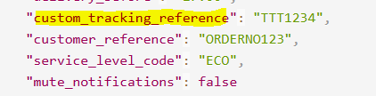

For custom tracking you would need to set a 3 letter prefix code in your account settings, it has to be unique 3 letters only, if another account has already used the 3 letters you would need to find a different set of unique letters.

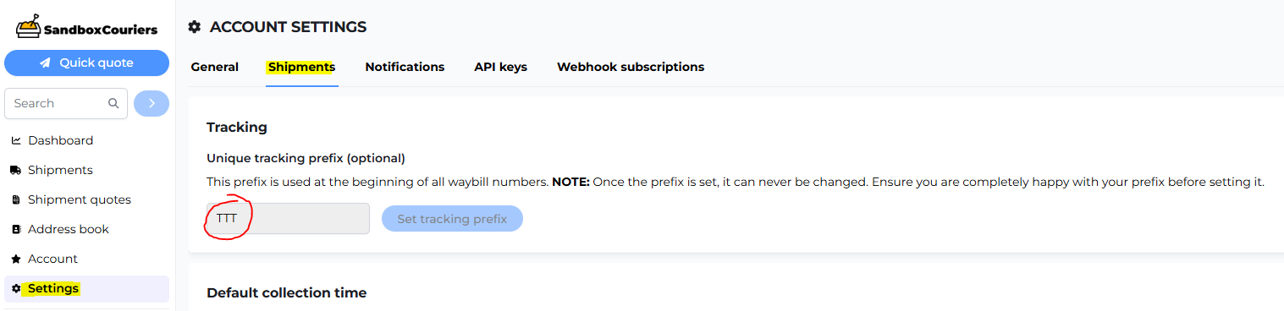

Tested with custom tracking prefix 123456
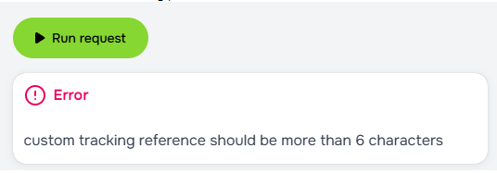

Tested with custom tracking prefix of 1234567

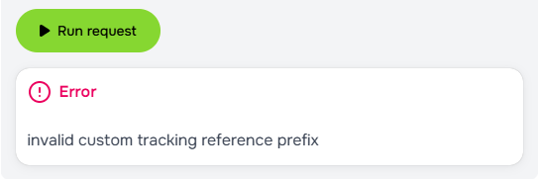

Tested with custom tracking prefix TTT1234 = working

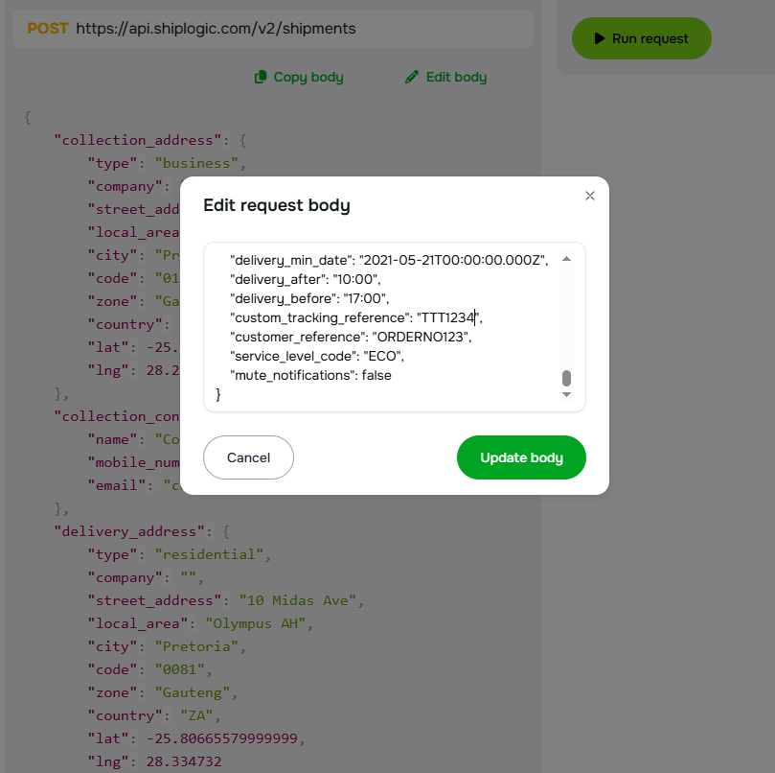

Result = Shipment: RD7MWL / TTT1234


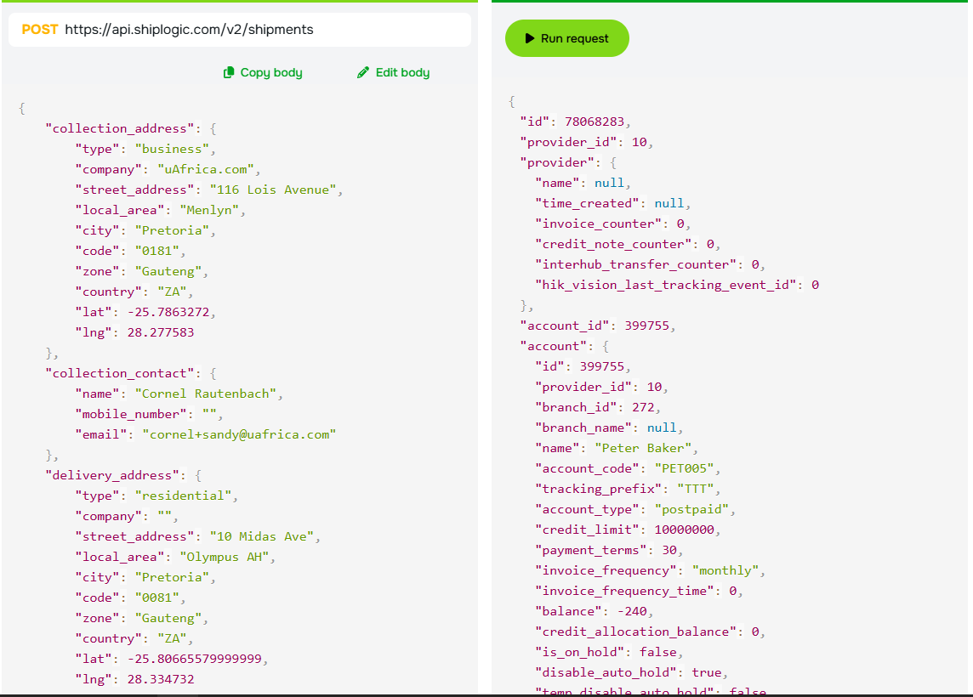

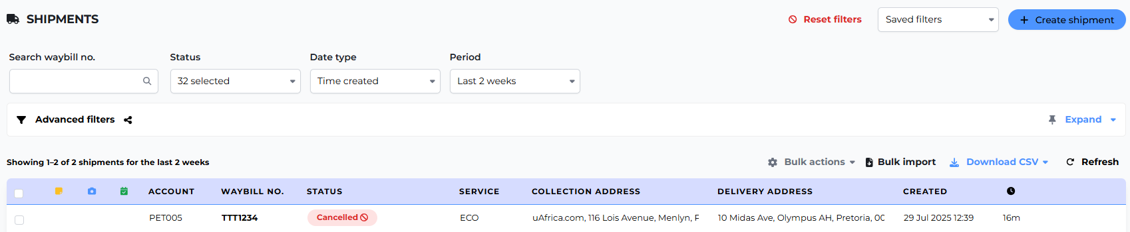

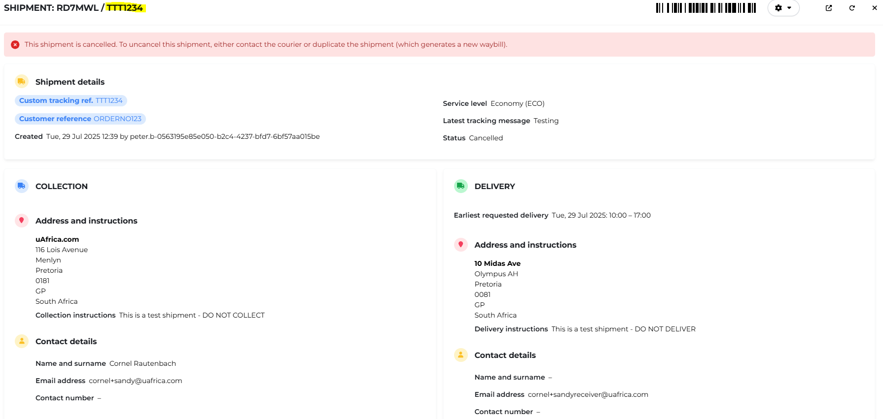

Zebra print API example

It is possible to get the ZPL via the API.
- The API endpoint is /shipments/label/stickers?format=zpl GET.
- Always add the format=zpl parameter.
- You can the use either id=123 or tracking_reference=ABC456 to get specify the shipment.
- The response is in JSON, but will contain the ZPL text for the sticker. Note that the response returns the stickers for each of the shipment’s parcels.
Here’s a sample response:
[
{
"id": 123,
"tracking_reference": "ABC456",
"parcel_waybills": [
{
"parcel_reference": "ABC456/1",
"sticker_waybill_content": "<zpl_sticker>"
},
{
"parcel_reference": "ABC456/2",
"sticker_waybill_content": "<zpl_sticker>"
}
]
}
]

Common Errors and mistakes

API calls could fail for any number of reasons, off the top of my head here's a checklist

API key invalid
Account on hold or locked
Not enough balance
Incorrect address or format or company name is different on Google maps
Incorrect province (this happens a lot)
No contact details or invalid format using minus as a separator “-“
Product shipping dimensions, either no dimensions or exceed the maximum of 800 x 800 x 800 @ 2000Kg (do not exceed 200 x 200 x 200 the volumetric = 2000Kg)
Invalid custom tracking reference
Incorrect Lat, Lng or set to zero (Please do not us zero)
Quote expired
Insurance/declared value exceeds R30k
Account credit limit is exceeded, or when an account’s geocoding rate limit is exceeded, I believe this is set to 10 000 for performance reasons (geocode limit is the number of API calls made in an hour)
Invalid endpoint is used
An invalid type is sent for a field, or a required field is missing.
Attempting to perform an invalid action, e.g. cancelling a shipment that has already been collected.
Error 422 Unprocessable Entity = Server attempts to email CSV or PDF files to the API user who has no email address (add a valid email address to the user settings resolve)

Ship Logic API https://www.shiplogic.com/api-docs

Change the token to Sandbox or Live (remember to cancel if you testing with live or sandbox)
Select Get Rate
Run the request
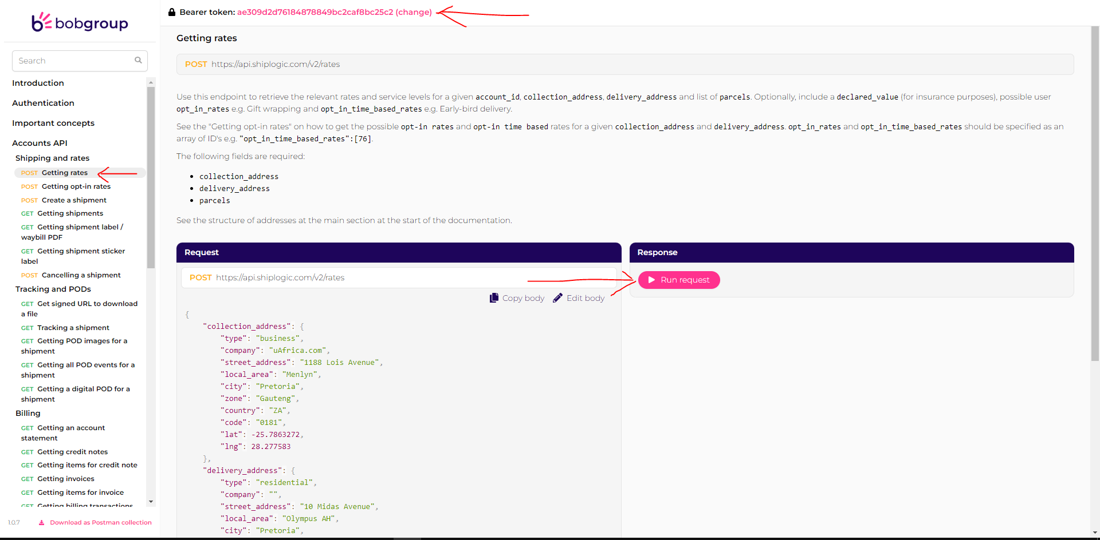

Below are the common reasons why you get an error

GPS co-ordinates

Tip: Do not use zero “0” for GPS co-ordinates when you are testing your API call, leave the field blank/empty if you do not know or set it to “null”

If you use zero you will pointing to the “Atlantic Ocean”

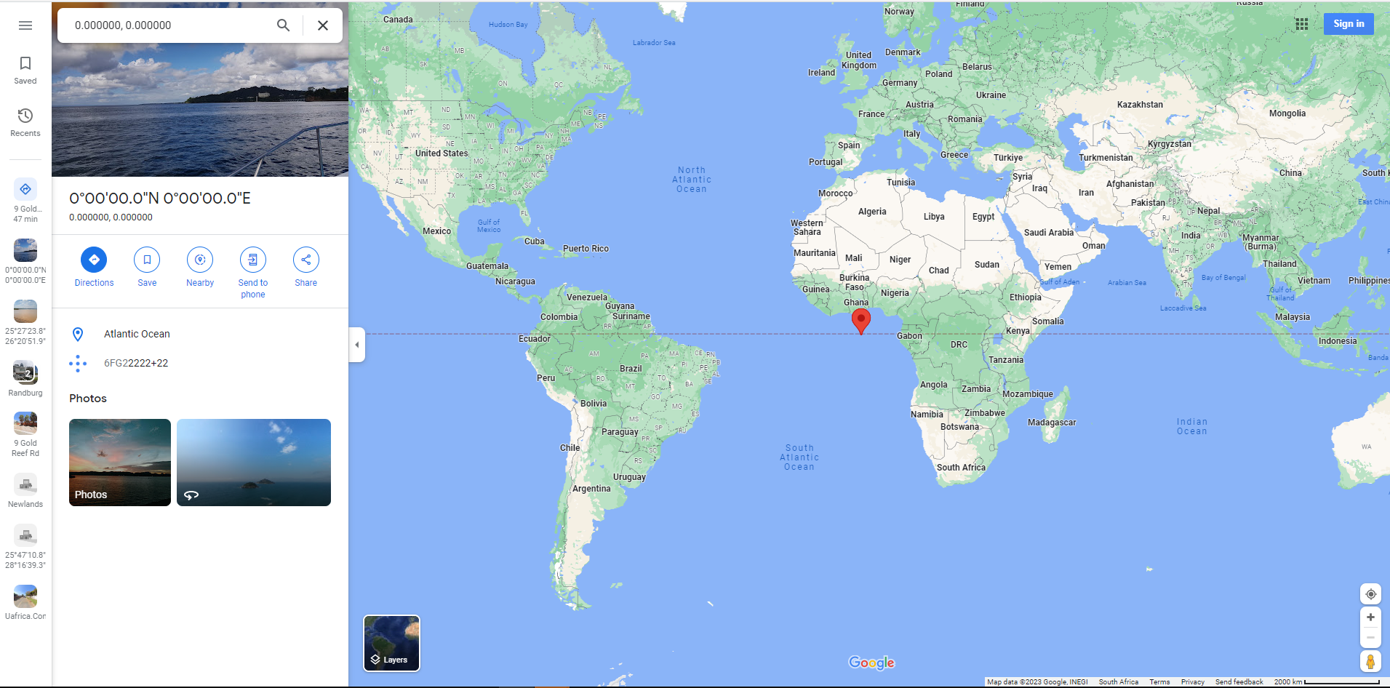

GPS example

You can use “null”
{
"collection_address": {
"type": "business",
"company": "uAfrica.com",
"street_address": "1188 Lois Avenue",
"local_area": "Menlyn",
"city": "Pretoria",
"zone": "Gauteng",
"country": "ZA",
"code": "0181",
"lat": null,
"lng": null
},
"delivery_address": {
"type": "residential",
"company": "",
"street_address": "10 Midas Avenue",
"local_area": "Olympus AH",
"city": "Pretoria",
"zone": "Gauteng",
"country": "ZA",
"code": "0081",
"lat": null,
"lng": null
},

Or remove “Lat” and “Lng”

{
"collection_address": {
"type": "business",
"company": "uAfrica.com",
"street_address": "1188 Lois Avenue",
"local_area": "Menlyn",
"city": "Pretoria",
"zone": "Gauteng",
"country": "ZA",
"code": "0181"
},
"delivery_address": {
"type": "residential",
"company": "",
"street_address": "10 Midas Avenue",
"local_area": "Olympus AH",
"city": "Pretoria",
"zone": "Gauteng",
"country": "ZA",
"code": "0081"
},

Example with customer_reference

{
"collection_address": {
"type": "business",
"company": "uAfrica.com",
"street_address": "116 Lois Avenue",
"local_area": "Menlyn",
"city": "Pretoria",
"code": "0181",
"zone": "Gauteng",
"country": "ZA",
"lat": -25.7863272,
"lng": 28.277583
},
"collection_contact": {
"name": "Cornel Rautenbach",
"mobile_number": "",
"email": "cornel+sandy@uafrica.com"
},
"delivery_address": {
"type": "residential",
"company": "",
"street_address": "10 Midas Ave",
"local_area": "Olympus AH",
"city": "Pretoria",
"code": "0081",
"zone": "Gauteng",
"country": "ZA",
"lat": -25.80665579999999,
"lng": 28.334732
},
"delivery_contact": {
"name": "",
"mobile_number": "",
"email": "cornel+sandyreceiver@uafrica.com"
},
"parcels": [
{
"parcel_description": "Standard flyer",
"submitted_length_cm": 20,
"submitted_width_cm": 20,
"submitted_height_cm": 10,
"submitted_weight_kg": 2
}
],
"opt_in_rates": [],
"opt_in_time_based_rates": [
76
],
"special_instructions_collection": "This is a test shipment - DO NOT COLLECT",
"special_instructions_delivery": "This is a test shipment - DO NOT DELIVER",
"declared_value": 1100,
"collection_min_date": "2021-05-21T00:00:00.000Z",
"collection_after": "08:00",
"collection_before": "16:00",
"delivery_min_date": "2021-05-21T00:00:00.000Z",
"delivery_after": "10:00",
"delivery_before": "17:00",
"custom_tracking_reference": "",
"customer_reference": "ORDERNO123",
"service_level_code": "ECO",
"mute_notifications": false
}

Services explained

Common mistake is trying to use the ECO service for every shipment (This only works on the Sandbox account, when you switch to a live account you must use the correct service)

Services are divided into 3 areas to cover South Africa.
local, national and regional depending on the "collection" and "delivery" address
Local :
If you only use flyers then use the LOF service for local deliveries
If you send flyers and parcels then use the LSE on sandbox because LOX is not available in sandbox testing
For “Local” use LOF or LSE (seems like there is no LOX on the sandbox)
For “National” ECO or OVN
For “Regional” ECOR or OVNR
For National and Regional areas the Volumetric Factor used to calculate is 4000 (formula = number of items x L x W x H /4000) must be in cm and Kg
MAX dimensions on our system are 800cm x 800cm x 800cm @ 2000Kg
Service level code | Service level name |  | Service level description |  |  | Volumetric factor |  |  | Weight from |  | Weight to | Weight unlimited
ECO | Economy |  | Expect delivery between 3 - 4 Days |  |  | 4000 |  |  | 25 |  |  | TRUE
ECOR | Economy Regional |  | Expect delivery between 3 - 5 Days |  |  | 4000 |  |  | 10 |  | 25 | FALSE
ECOR | Economy Regional |  | Expect delivery between 3 - 5 Days |  |  | 4000 |  |  | 15 |  | 25 | FALSE
ECO | Economy |  | Expect delivery between 3 - 4 Days |  |  | 4000 |  |  | 10 |  | 25 | FALSE
ECO | Economy |  | Expect delivery between 3 - 4 days. |  |  | 4000 |  |  | 0 |  | 5 | FALSE
ECO | Economy |  | Expect delivery between 3 - 4 days. |  |  | 4000 |  |  | 5 |  | 10 | FALSE
ECO | Economy |  | Expect delivery between 3 - 4 days. |  |  | 4000 |  |  | 0 |  | 15 | FALSE
ECO | Economy |  | Expect delivery between 3 - 4 days. |  |  | 4000 |  |  | 15 |  | 25 | FALSE
ECO | Economy |  | Expect delivery between 3 - 4 days. |  |  | 4000 |  |  | 0 |  |  | TRUE
ECOB | Economy Bulk Kiosk |  | Expect delivery between 3 - 4 days. |  |  | 4000 |  |  | 100 |  |  | TRUE
ECOR | Economy Regional |  | Expect delivery between 3 - 5 days. |  |  | 4000 |  |  | 0 |  | 5 | FALSE
ECOR | Economy Regional |  | Expect delivery between 3 - 5 days. |  |  | 4000 |  |  | 5 |  | 10 | FALSE
ECOR | Economy Regional |  | Expect delivery between 3 - 5 days. |  |  | 4000 |  |  | 0 |  | 15 | FALSE
ECOR | Economy Regional |  | Expect delivery between 3 - 5 days. |  |  | 4000 |  |  | 25 |  |  | TRUE
ECORB | Economy Regional Bulk Kiosk |  | Expect delivery between 3 - 5 days. |  |  | 4000 |  |  | 100 |  |  | TRUE
ECOR | Economy Regional |  | Expect delivery between 3 - 5 days. |  |  | 4000 |  |  | 0 |  |  | TRUE
ECO | Economy |  | Expect delivery between 3 - 4 Days |  |  | 4000 |  |  | 5 |  | 15 | FALSE
ECOR | Economy Regional |  | Expect delivery between 3 - 5 Days |  |  | 4000 |  |  | 5 |  | 15 | FALSE
ECO | Economy |  | Expect delivery between 3 - 4 days. |  |  | 4000 |  |  | 40 |  |  | TRUE
For local deliveries it is cheaper to send 1 parcel
For local, overnight regional and international areas the Volumetric Factor used to calculate is 5000 (formula = number of items x L x W x H /5000) must be in cm and Kg
Service level code | Service level name |  | Service level description |  |  | Volumetric factor |  |  | Weight from |  | Weight to | Weight unlimited
OVNR | Overnight Regional |  | Expect delivery between 2 - 3 Days |  |  | 5000 |  |  | 0 |  |  | TRUE
RIN | International Road |  |  |  |  | 5000 |  |  | 0 |  |  | TRUE
LLX | Local Late Same day Express |  | Collection same day after 15:00, but before 17:00, delivery after 90 minutes. |  |  | 5000 |  |  | 0 |  | 40 | FALSE
INN | International |  | Contact your nearest hub for transit times. |  |  | 5000 |  |  | 0 |  | 30 | FALSE
LOF | Local Overnight Flyer |  | Collection must be booked by 14:00, and ready by 14:30, to be delivered during the next business day. |  |  | 5000 |  |  | 0 |  | 15 | FALSE
LOX | Local Overnight Parcel |  | Collection must be booked by 14:00, and ready by 14:30, to be delivered during the next business day. |  |  | 5000 |  |  | 0 |  | 40 | FALSE
LSE | Local Same Day Economy |  | Collection must be booked by 10:30, and ready by 11:00, to be delivered by 17:00 the same day. |  |  | 5000 |  |  | 0 |  | 40 | FALSE
LSF | Local Same Day Flyer |  | Collection must be booked by 10:30, and ready by 11:00, to be delivered by 17:00 the same day. |  |  | 5000 |  |  | 0 |  | 15 | FALSE
LSX | Local Same day Express |  | Collection same day after 8:00 but before 15:00, delivery within 90 minutes. |  |  | 5000 |  |  | 0 |  | 40 | FALSE
OVNR | Overnight Regional |  | Expect delivery between 2 - 3 days. |  |  | 5000 |  |  | 0 |  |  | TRUE
OVN | Overnight |  | Expect delivery between 1 - 2 days. |  |  | 5000 |  |  | 0 |  |  | TRUE
LOX | Local Overnight Parcel Ecomms |  | Collection must be booked by 14:00, and ready by 14:30, to be delivered during the next business day. |  |  | 5000 |  |  | 0 |  |  | TRUE
LSE | Local Same Day Economy Ecomms |  | Collection must be booked by 10:30, and ready by 11:00, to be delivered by 17:00 the same day. |  |  | 5000 |  |  | 0 |  |  | TRUE
Recommend a trigger for example North West = ECOR unless Potchefstroom then = ECO
ECO and OVN Main areas Orange/Purple | Province |  | Service expected
Johannesburg | Gauteng |  | ECO
Pretoria | Gauteng |  | ECO
Bloemfontein | Free State |  | ECO
Cape Town | Western Cape |  | ECO
Durban | KwaZulu-Natal |  | ECO
Port Elizabeth | Eastern Cape |  | ECO
East London | Eastern Cape |  | ECO
George | Western Cape |  | ECO
Kimberley | Northern Cape |  | ECO
Ladysmith | KwaZulu-Natal |  | ECO
Nelspruit | Mpumalanga |  | ECO
Polokwane | Limpopo |  | ECO
Potchefstroom | Northwest |  | ECO
Welkom | Free State |  | ECO
Witbank | Mpumalanga |  | ECO
Provinces | Service expected
Eastern Cape | ECOR
Free State | ECOR
Gauteng | ECO
KwaZulu-Natal | ECO
Limpopo | ECOR
Mpumalanga | ECOR
Northern Cape | ECOR
North West | ECOR
Western Cape | ECO

The Courier Guy Geo mapping
Orange to same orange = local
Orange to another orange/purple = national
Anything "from" or "To" Blue/black = regional

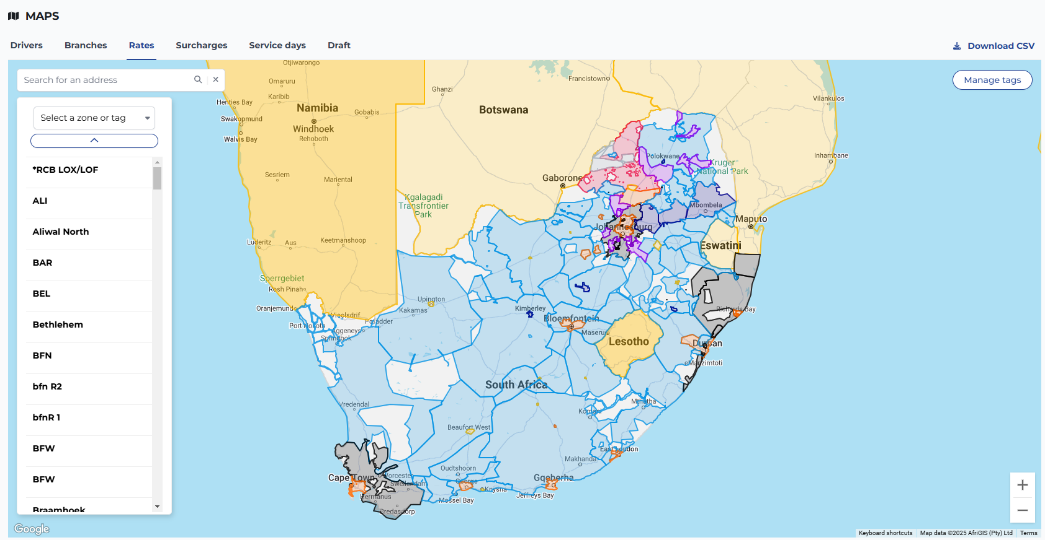

I use the below formula in bulk imports excel template to work out what service to use for LOX, ECO and ECOR -> column U3 is the City field in the delivery address and V3 is the delivery province (set below highlight to collection province, can be Gauteng, Western Cape or Kwazulu-Natal only to get LOX if you collect from another province then use ECOR for everything if the city is not one of the main ones)

Example of Gauteng collection
=IF(OR(U3="Bloemfontein",U3="Cape Town",U3="Durban",U3="Port Elizabeth",U3="East London",U3="George",U3="Kimberley",U3="Ladysmith",U3="Nelspruit",U3="Polokwane",U3="Potchefstroom",U3="Welkom",U3="Witbank"), "ECO", IF(V3="Gauteng", "LOX", IF(OR(V3="Western Cape", V3="KwaZulu-Natal"), "ECO", "ECOR")))

Example of Kwazulu-Natal collection
=IF(OR(U3="Bloemfontein",U3="Cape Town",U3="Durban",U3="Port Elizabeth",U3="East London",U3="George",U3="Kimberley",U3="Ladysmith",U3="Nelspruit",U3="Polokwane",U3="Potchefstroom",U3="Welkom",U3="Witbank"), "ECO", IF(V3="KwaZulu-Natal", "LOX", IF(OR(V3="Western Cape", V3="Gauteng"), "ECO", "ECOR")))

No LOX on sandbox
You can use ECO for everything on sandbox…not on live site
Prices are DEMO prices
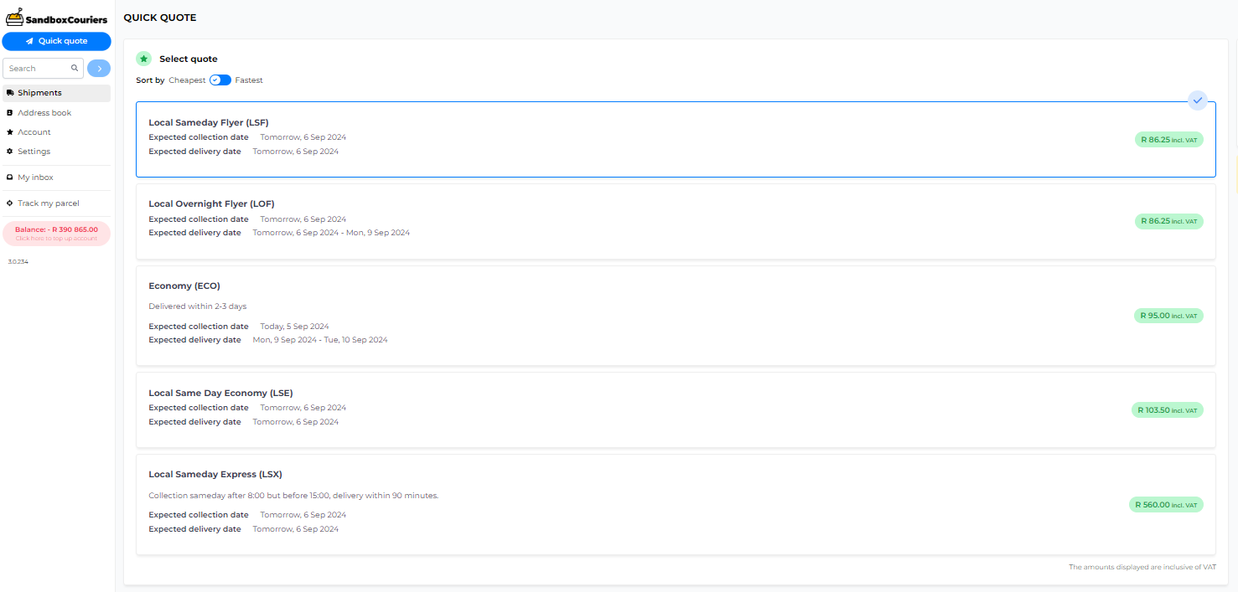

API call for shipment notes
You can use the following GET endpoint https://api.shiplogic.com/v2/shipments/notes/external?shipment_id=123

This is an example response:

- {
- "shipment_notes": [
- {
- "shipment_id": 37370,
- "message": "<p><strong>This is a test note.</strong></p>",
- "attachments": null,
- "time_created": "2024-04-10T12:13:54.501Z",
- "time_modified": "2024-04-10T12:13:54.687054Z"
- }
- ],
- "count": 1
- }

API error for stickers over 30 parcels, response from the developers.

Please note that there is a limit of 30 parcels to generate the stickers without emailing it to the client.
In this case there are 41 parcels on the shipment which is why the system attempts to email the labels but API users do not have email linked to them, hence the error.

I would recommend paging the request and pulling the info in 2 request

?limit=20&offset=0

If you have any questions or need assistance with this integration, please contact us by sending an email to it@thecourierguy.co.za
If we are unable to assist we can escalate to the Ship Logic developers at support@shiplogic.com

Error = The JSON value could not be converted to System.String. Path: $.rates[0].rate_adjustments[0]

How to Fix It
- Update your Model Class:
Change the rate_adjustments property from a string to a matching object type or a of a custom class.
public class Rate
{
// Instead of public string rate_adjustments { get; set; }
public List<RateAdjustment> rate_adjustments { get; set; }
}

public class RateAdjustment
{
// Define fields based on the API response (e.g., name, value, type)
public string type { get; set; }
public decimal amount { get; set; }
}

- Use JsonElement for Dynamic Data:
If you don't want to create a full class for every adjustment, change the property type to JsonElement. This allows the serializer to hold the raw JSON without trying to force it into a string.
- Switch to Newtonsoft.Json:
If the API response structure is highly unpredictable, Newtonsoft.Json (Json.NET) is generally more lenient with type mismatches than System.Text.Json.
Why it's happening
System.Text.Json is "strict" by design. It will fail if it encounters an opening brace { or bracket [ when it expects a quote ". Since rate_adjustments[0] is the first item in an array, the serializer found an object where it expected a text value.

Example response from sanbox = empty square brackets
},
"surcharges": [],
"rate_adjustments": [],
"time_based_rate_adjustments": [],
"extras": [
{
"id": 245291,
"insurance_charge": 25,
"vat": 3.2608695652173907,
"vat_type": "standard"
}

Testing High risk from live, with a fuel surcharge, now you can see the fields that should be in the square brackets

},
"surcharges": [
{
"id": 2626861,
"group_id": 242345,
"name": "High risk",
"charge": 80.5,
"vat": 10.5,
"vat_type": "standard"
}
],
"rate_adjustments": [
{
"id": 756742,
"group_id": 242345,
"name": "Fuel surcharge",
"charge": 21.735,
"is_opt_in": false,
"opted_in_by_default": false,
"vat": 2.8356521739130436,
"vat_type": "standard",
"description": ""
}
],

Error: Type Mismatch on Empty Array Properties
Error Message
Error: The JSON value could not be converted to System.String. Path: $.rates[0].rate_adjustments[0]
Cause
This error occurs in strictly typed languages (like C#/.NET) when the API client deserializes an empty JSON array [] into a property expected to be a System.String or a single object, rather than a list or array type.
In the Sandbox environment, fields like rate_adjustments or surcharges may return as empty square brackets [] if no adjustments apply. In the Live environment, when surcharges (e.g., High Risk) or rate adjustments (e.g., Fuel Surcharge) are active, these fields populate as an array of objects.
How to Rectify
Update your data models and classes to ensure these properties are explicitly defined as arrays, lists, or collections of objects rather than strings.
- Incorrect Model Definition (C# Example):
csharp
// This will throw an error when the API returns [] or populated arrays
public string rate_adjustments { get; set; }
Use code with caution.
- Correct Model Definition (C# Example):
csharp
// Define the property as a List of the specific object type
public List<RateAdjustment> rate_adjustments { get; set; }

public class RateAdjustment
{
public int id { get; set; }
public int group_id { get; set; }
public string name { get; set; }
public double charge { get; set; }
public bool is_opt_in { get; set; }
public bool opted_in_by_default { get; set; }
public double vat { get; set; }
public string vat_type { get; set; }
public string description { get; set; }
}
Use code with caution.

